Assignment 2

To copy it from one ec2 server to 2 app server for that you need to 1st download apache tomcat server.

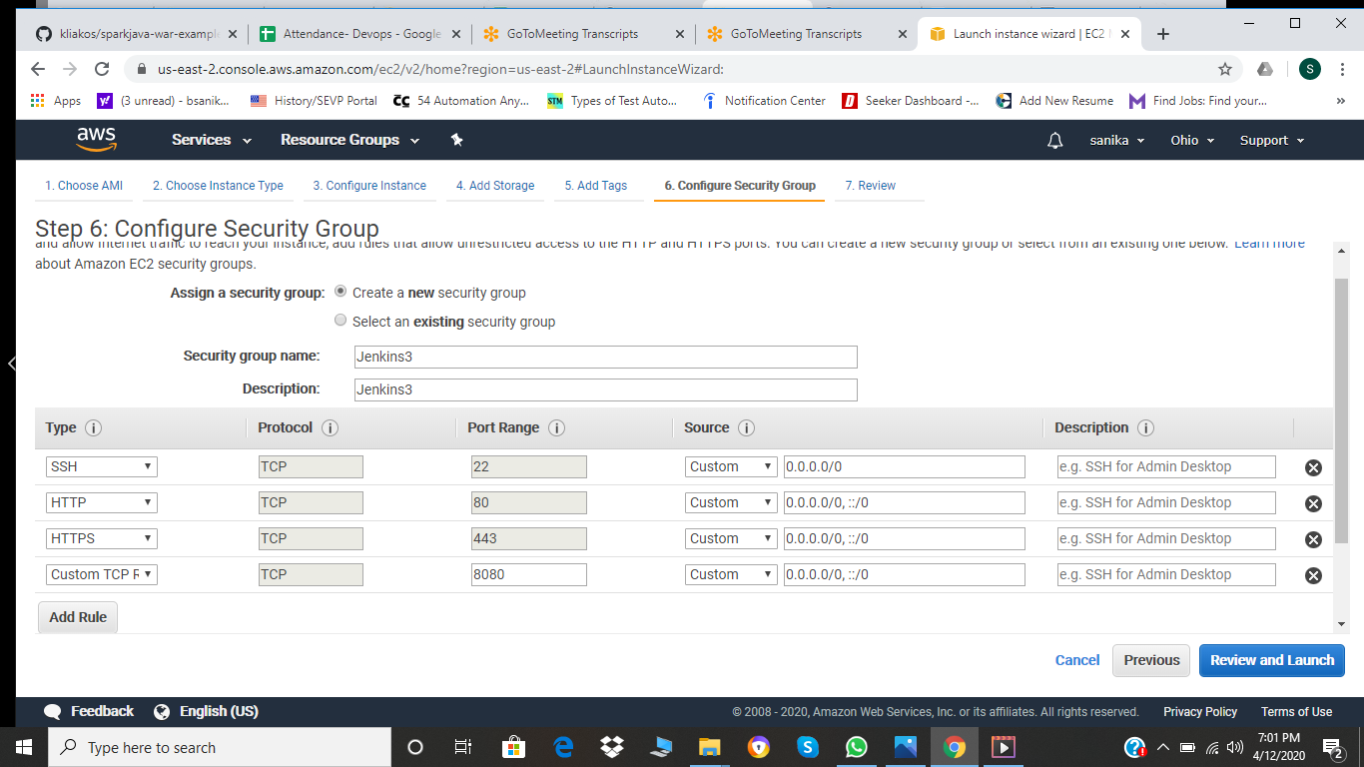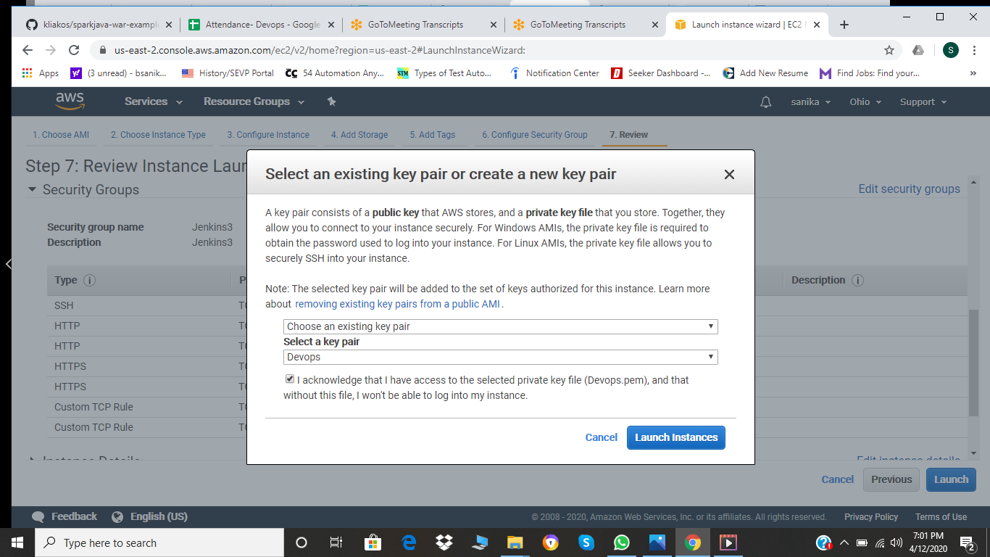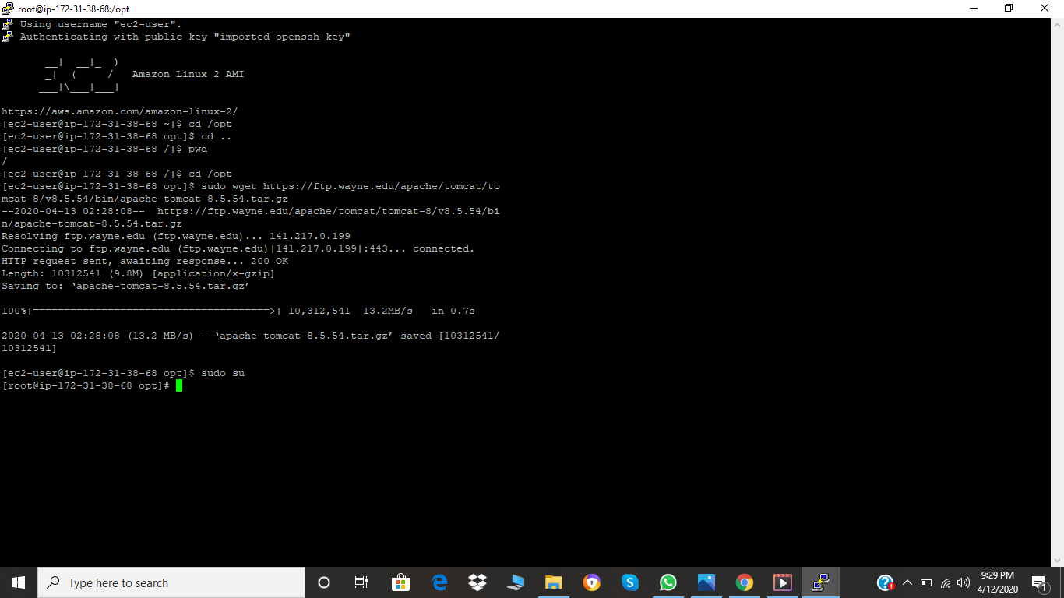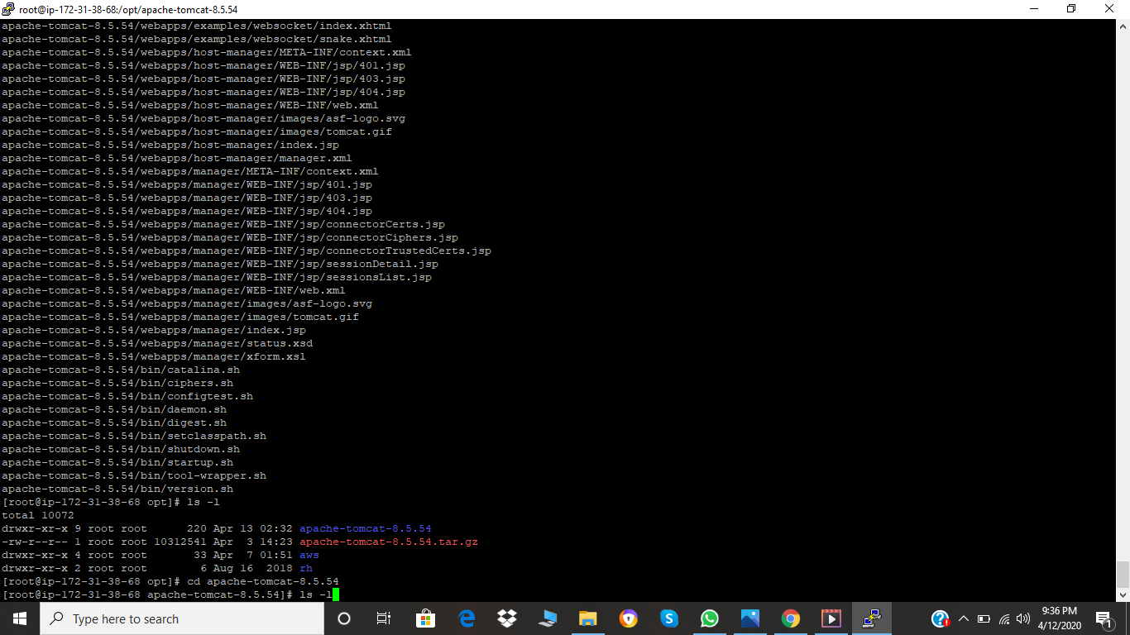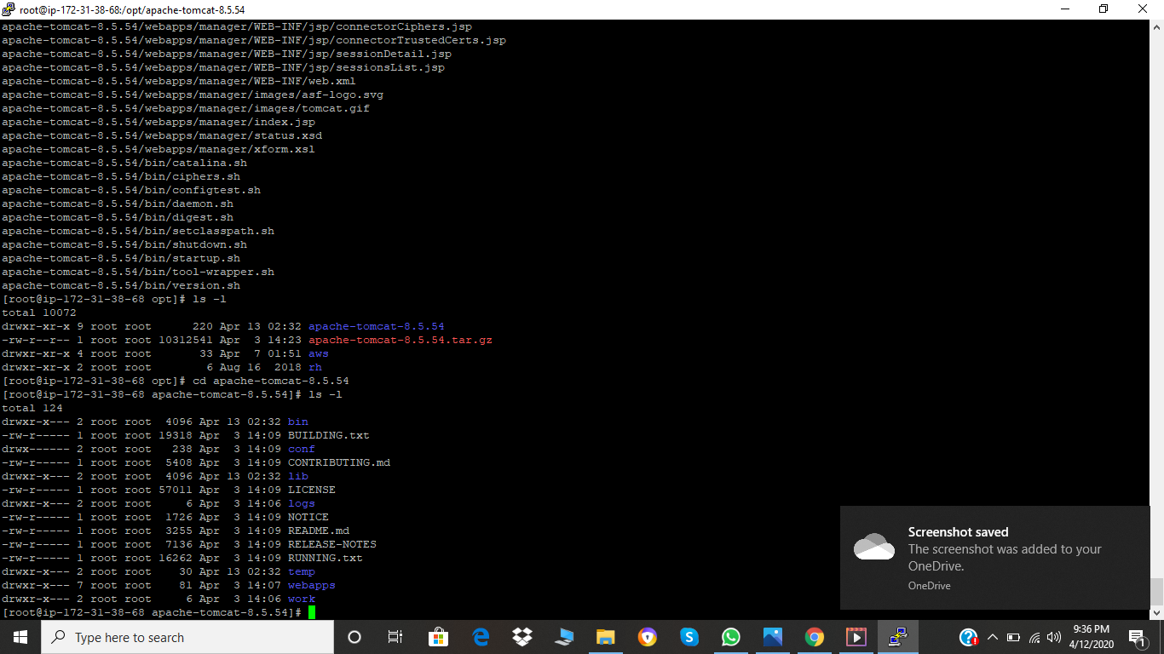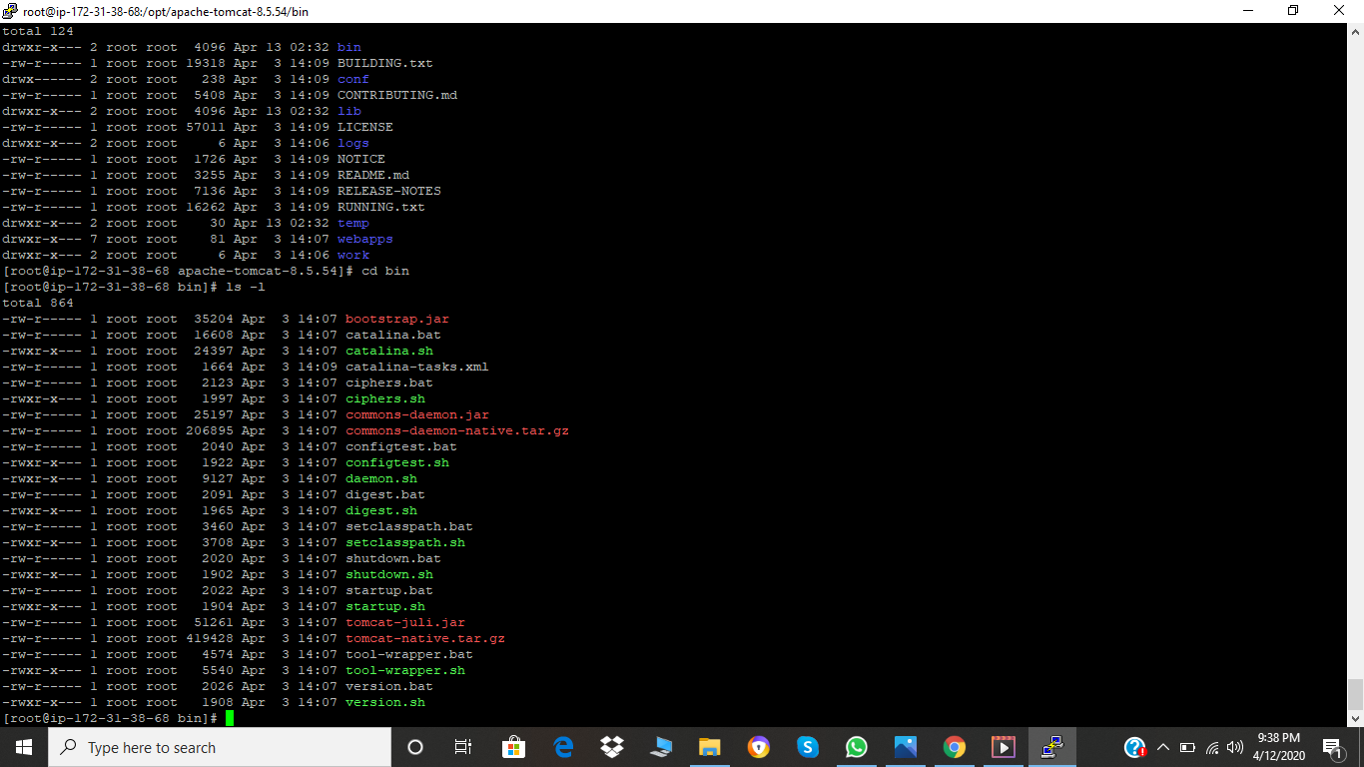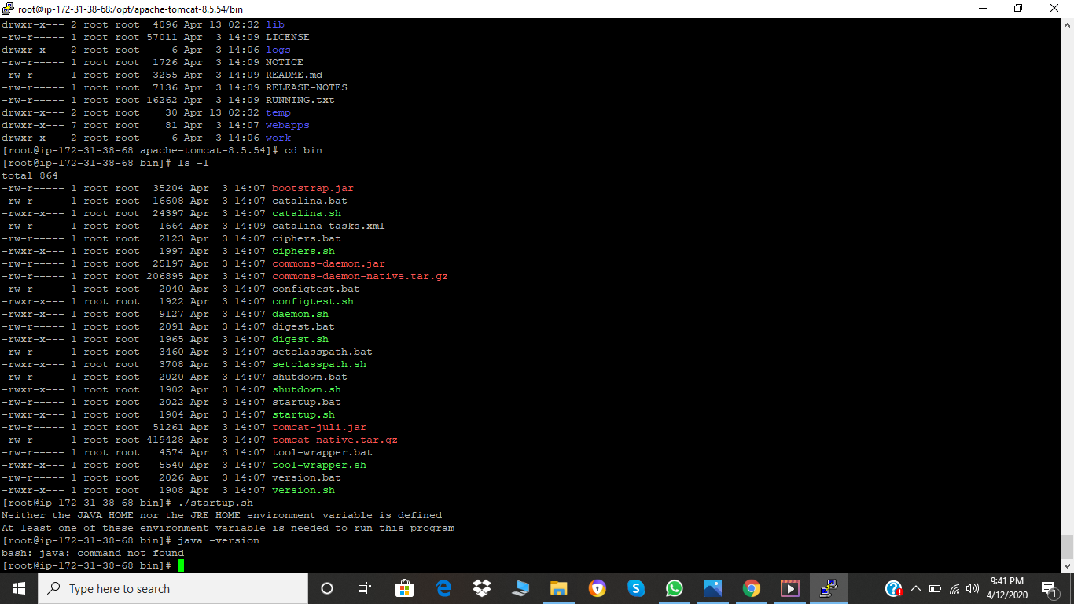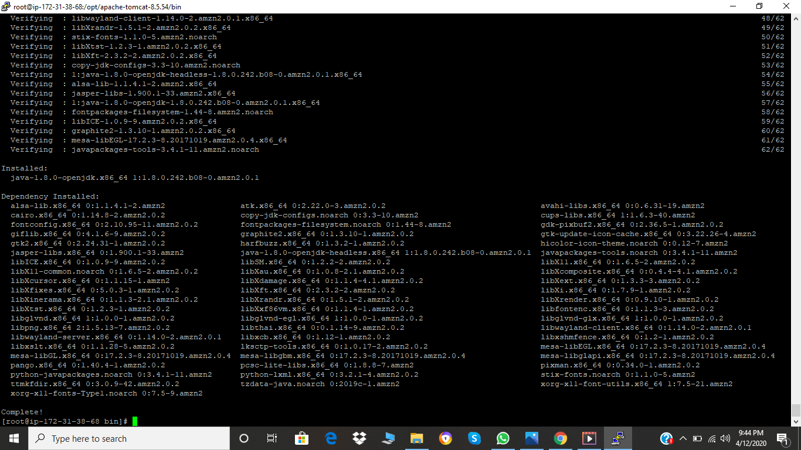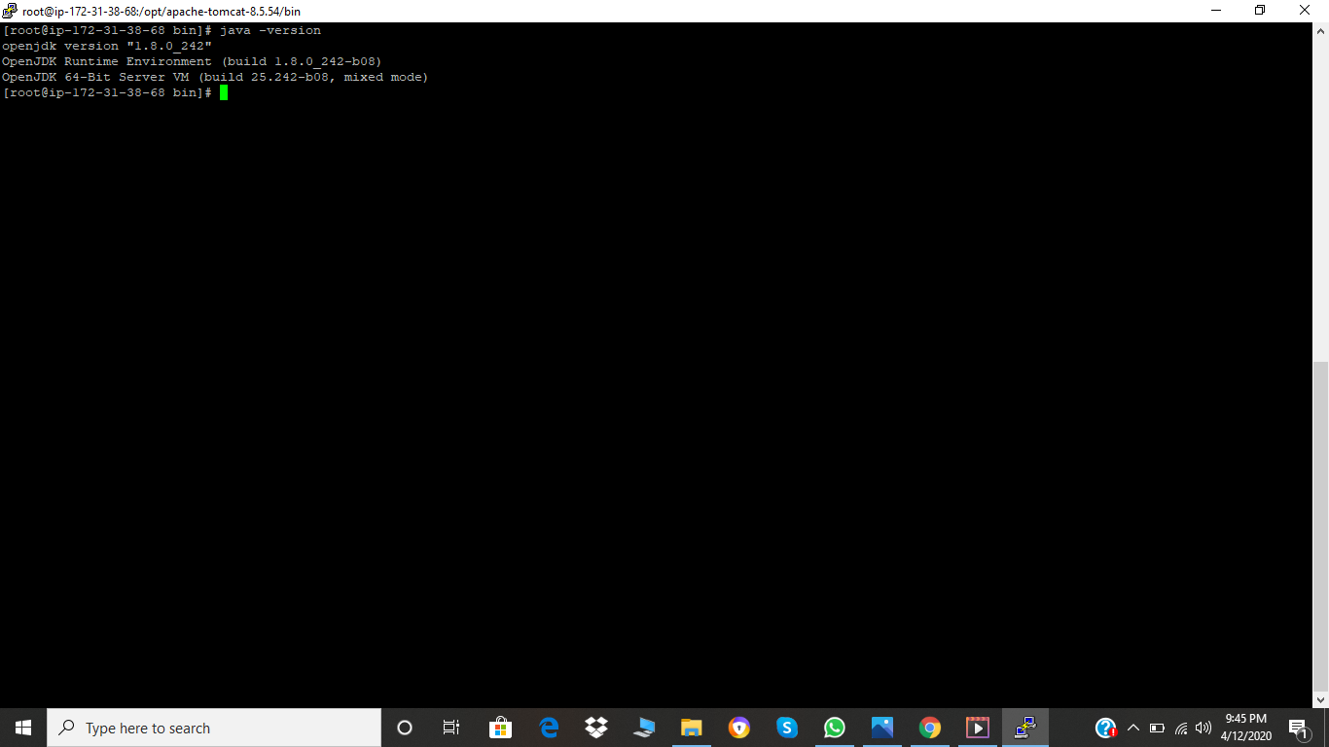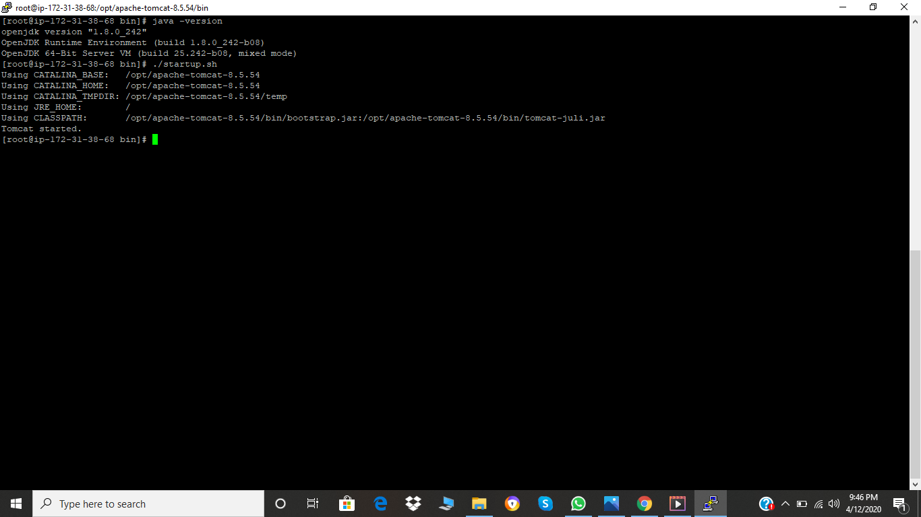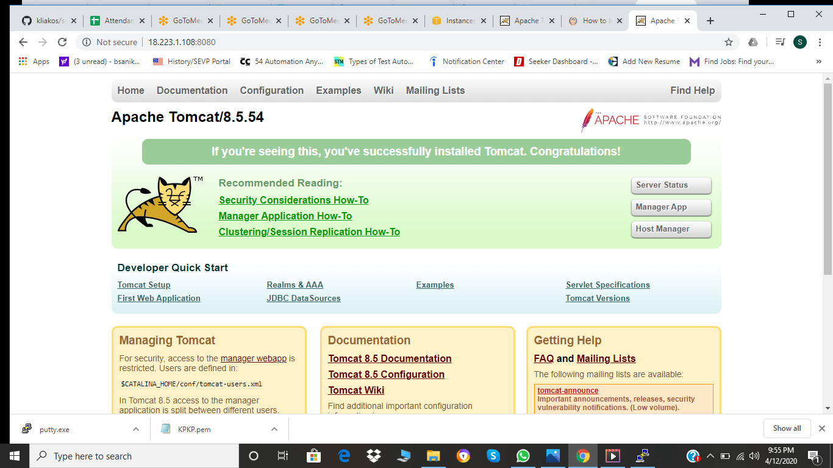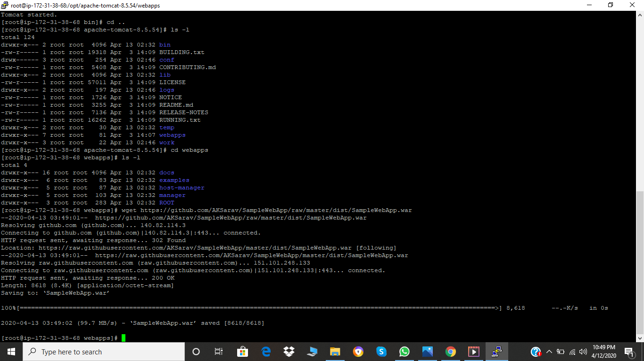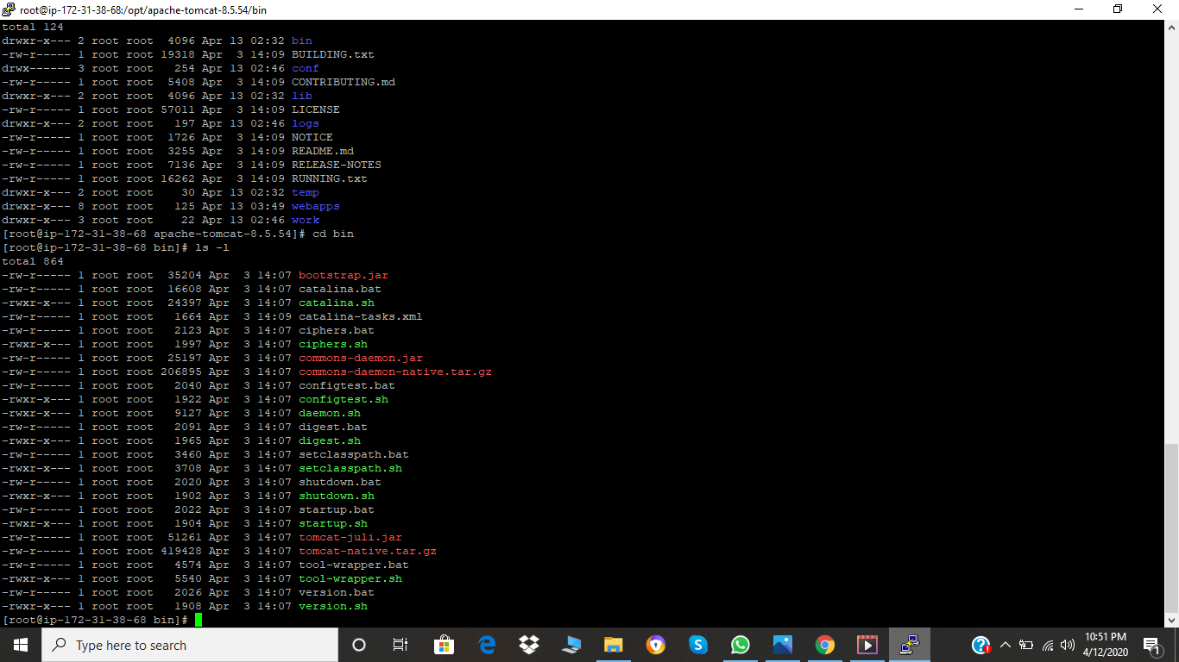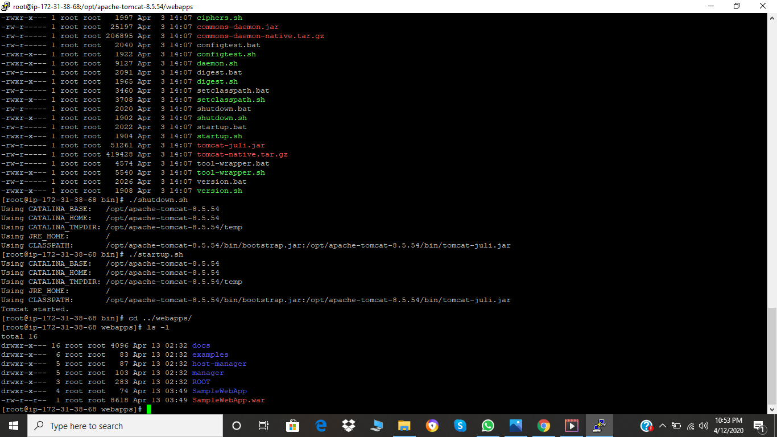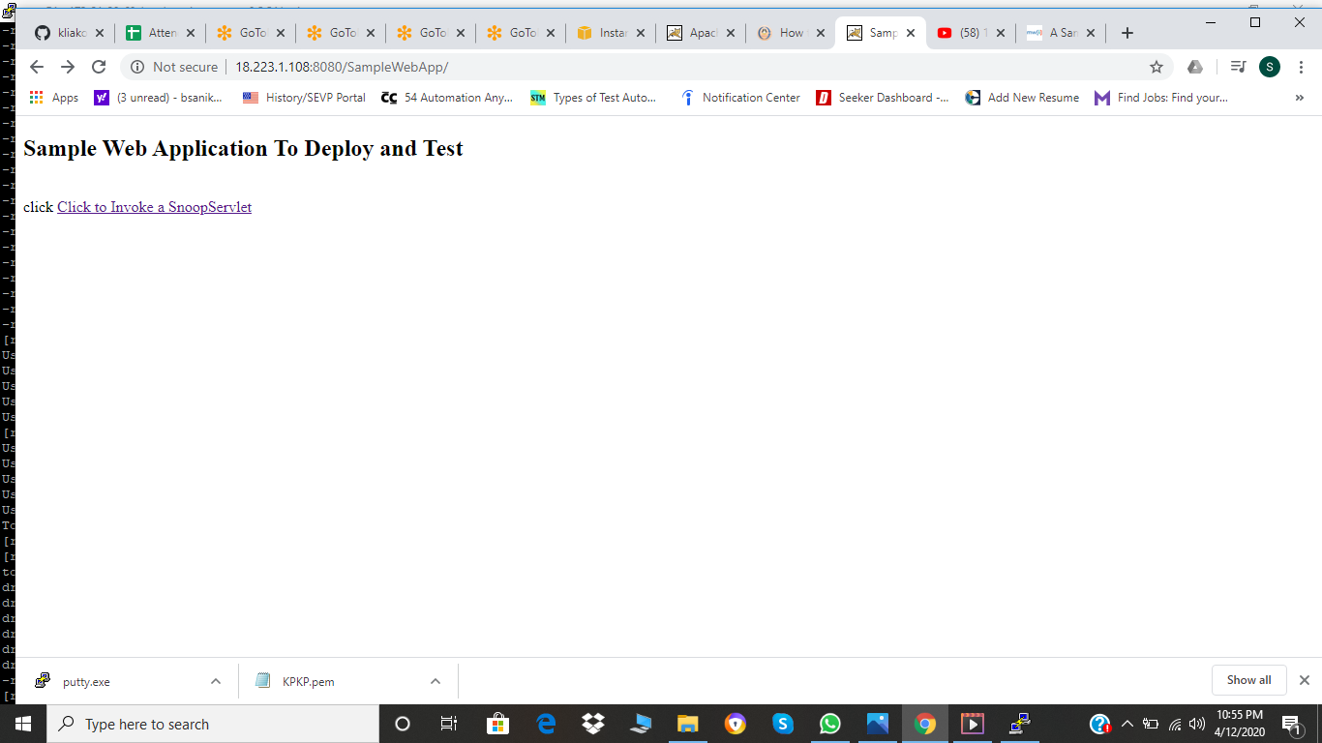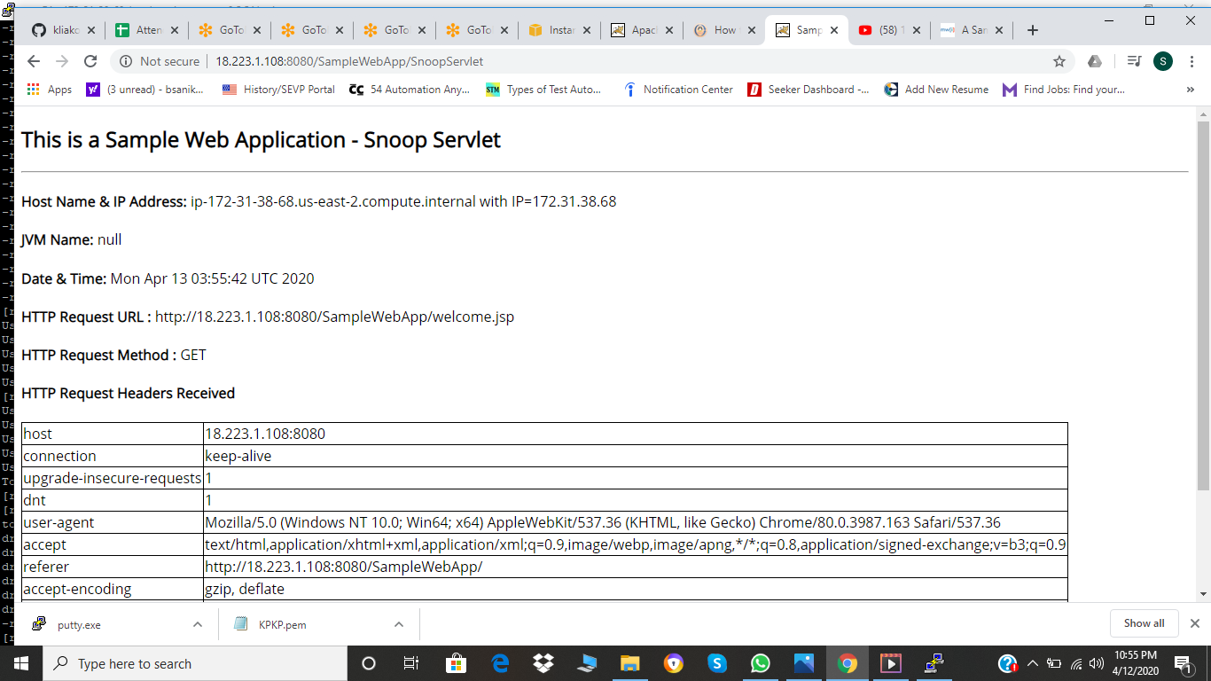

Then we have to download Jenkins on the server

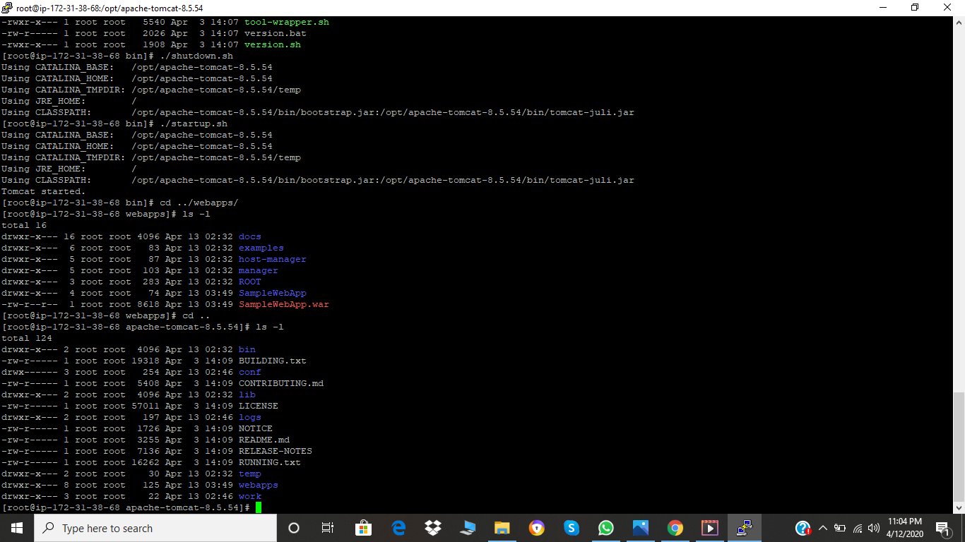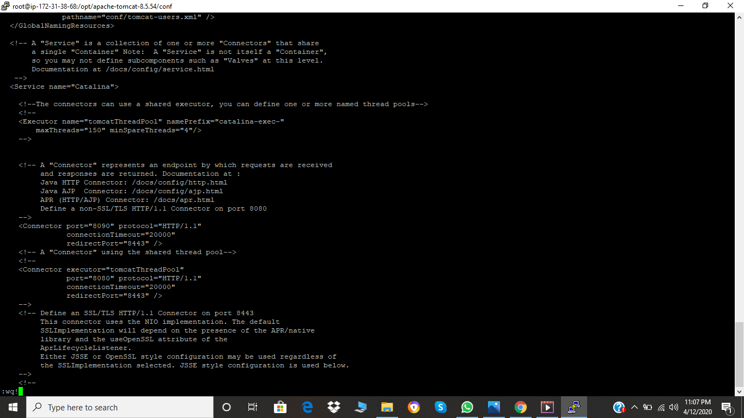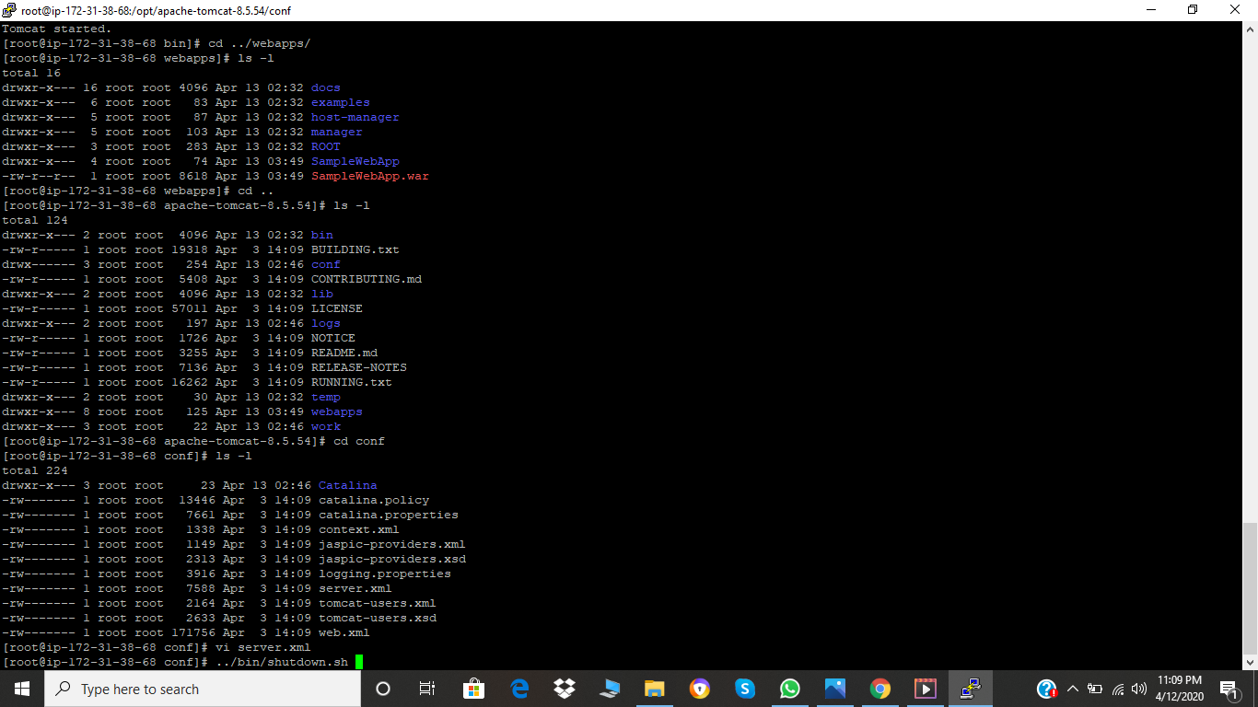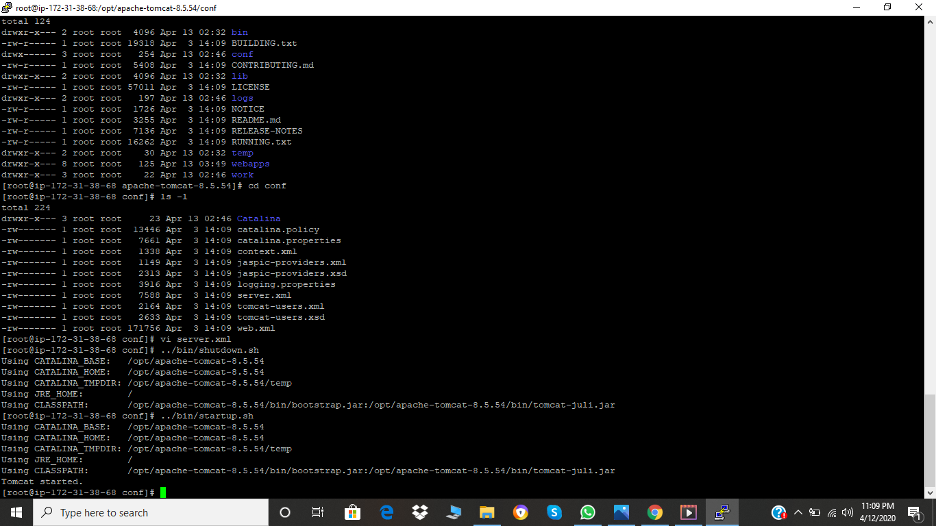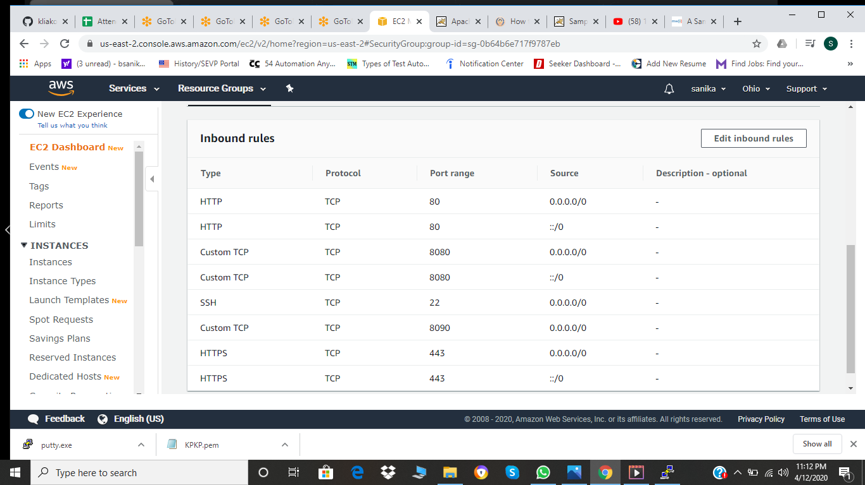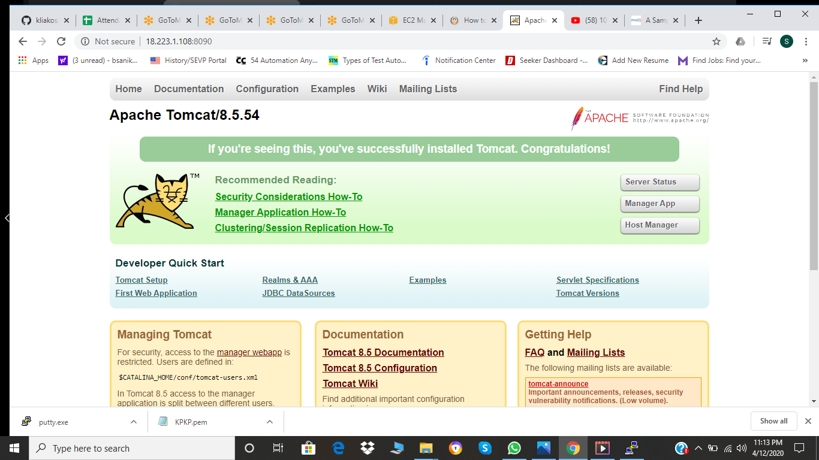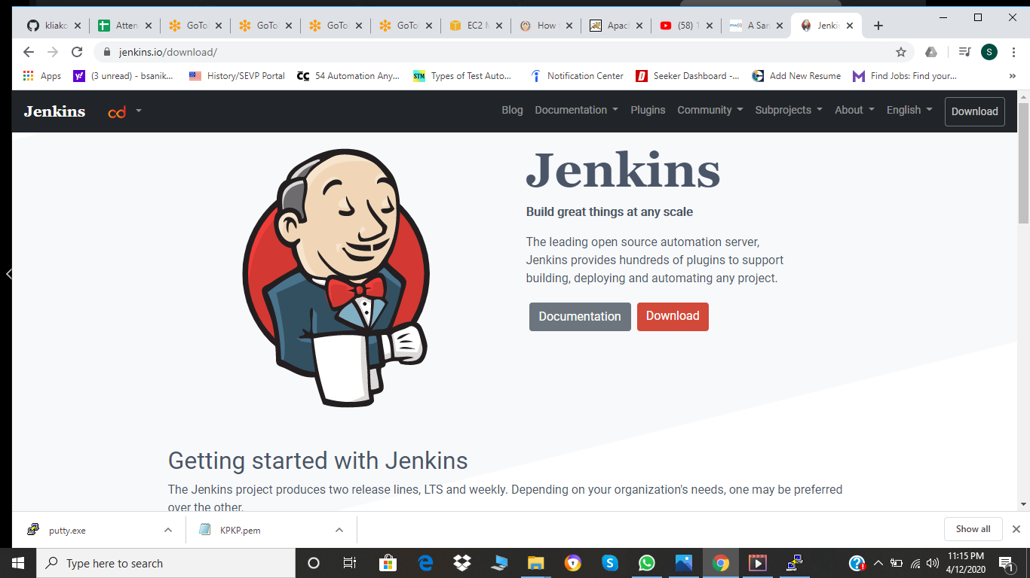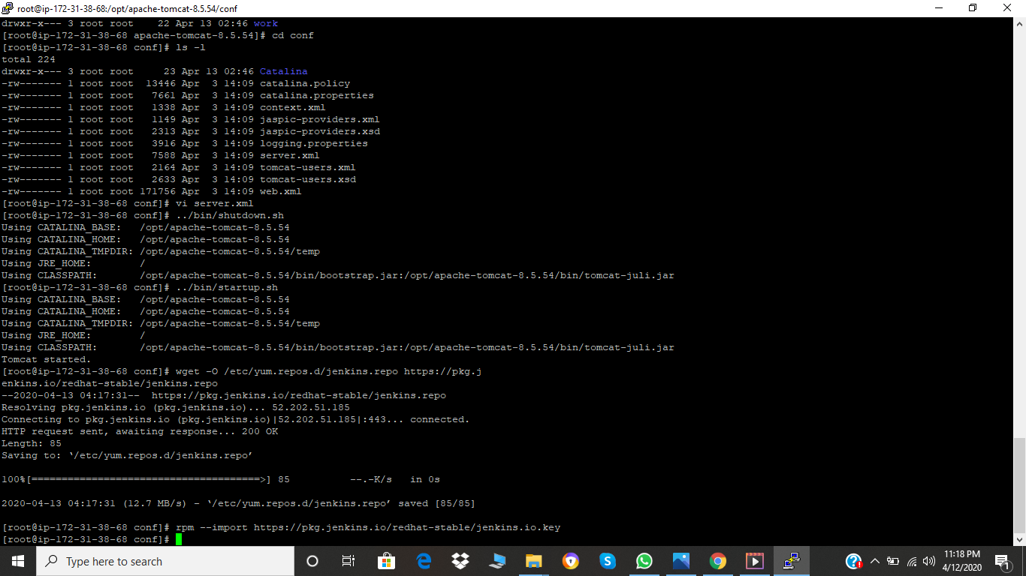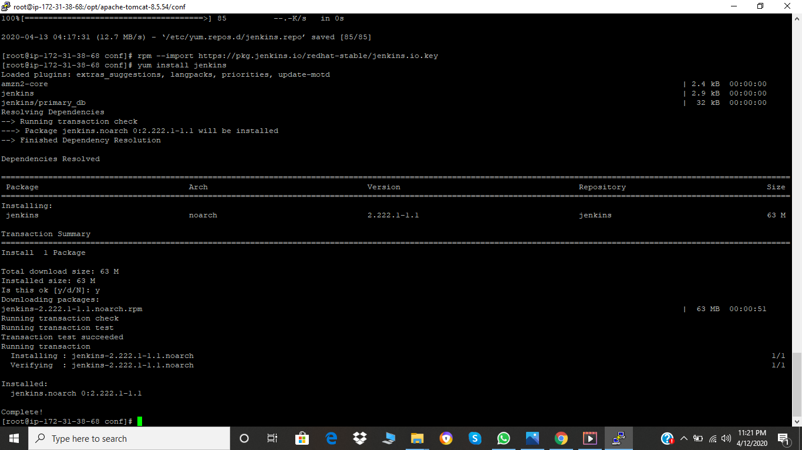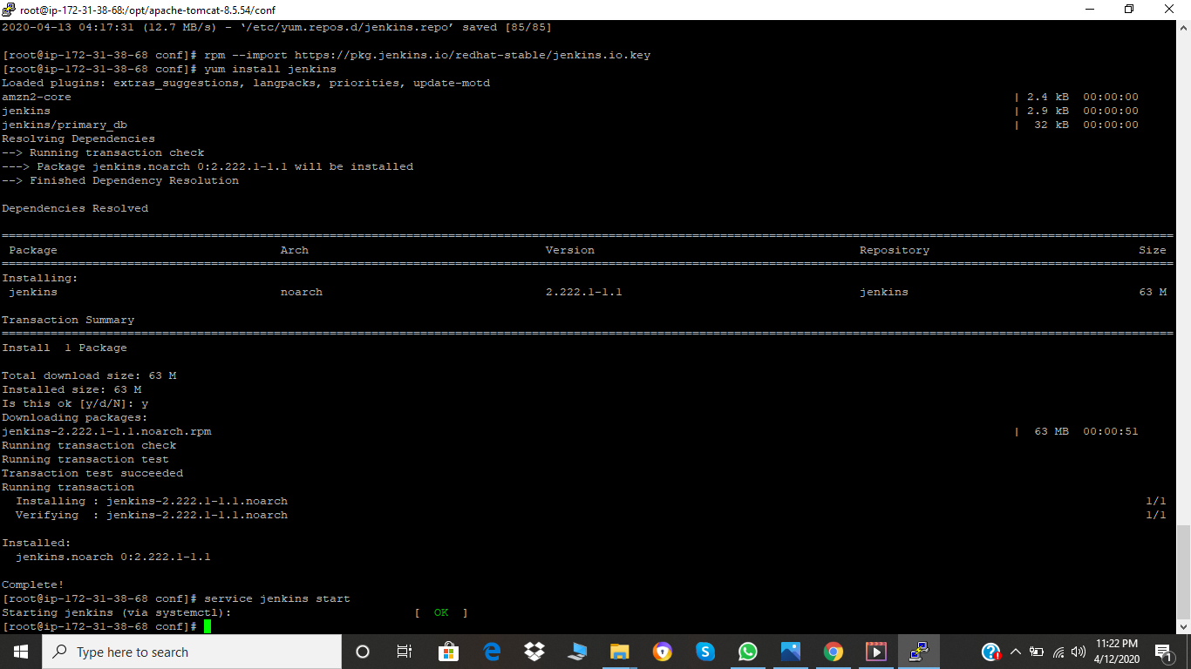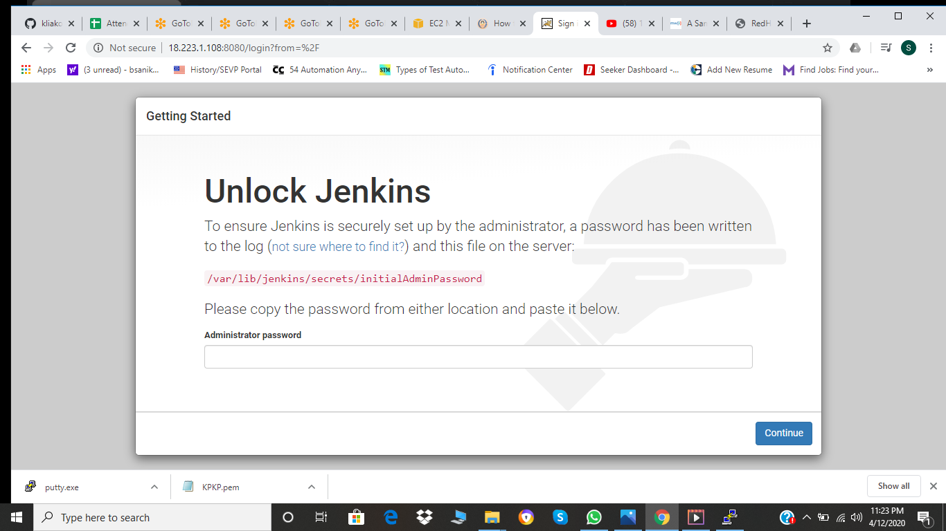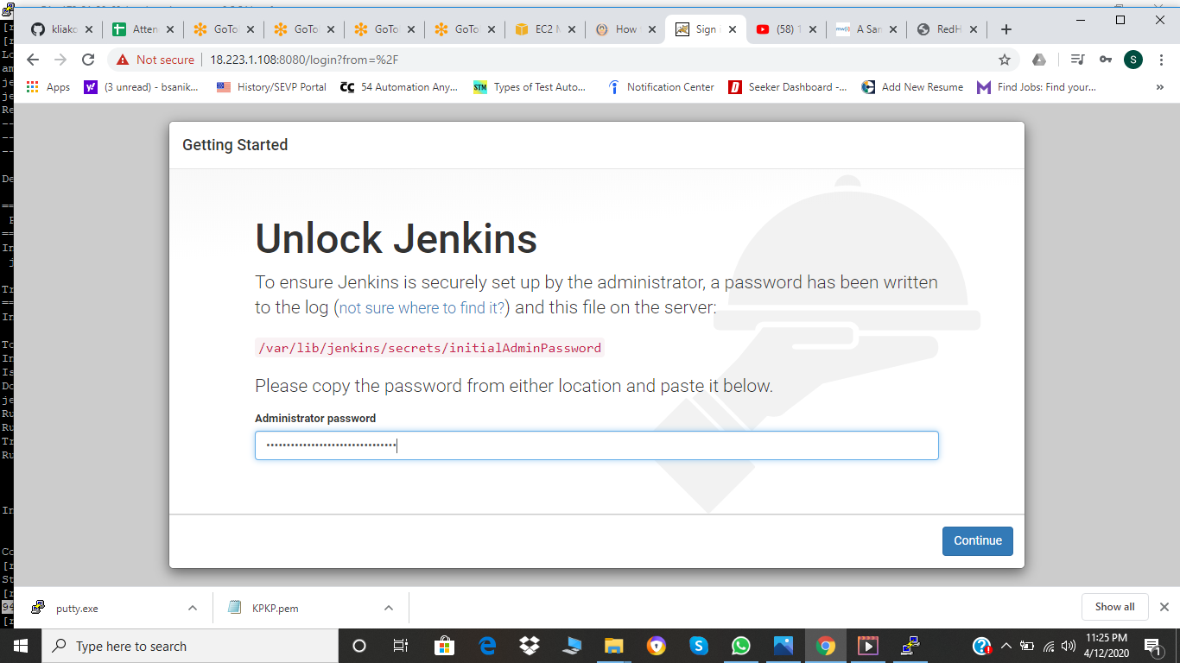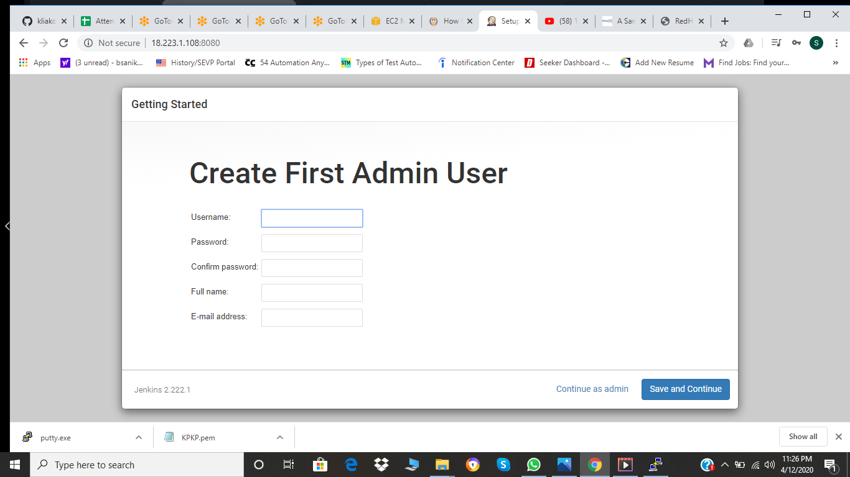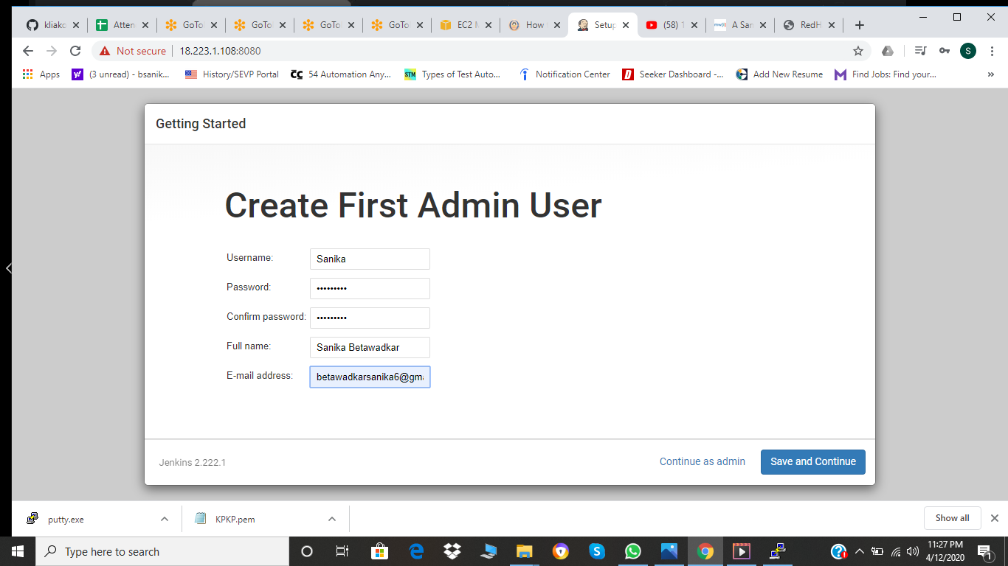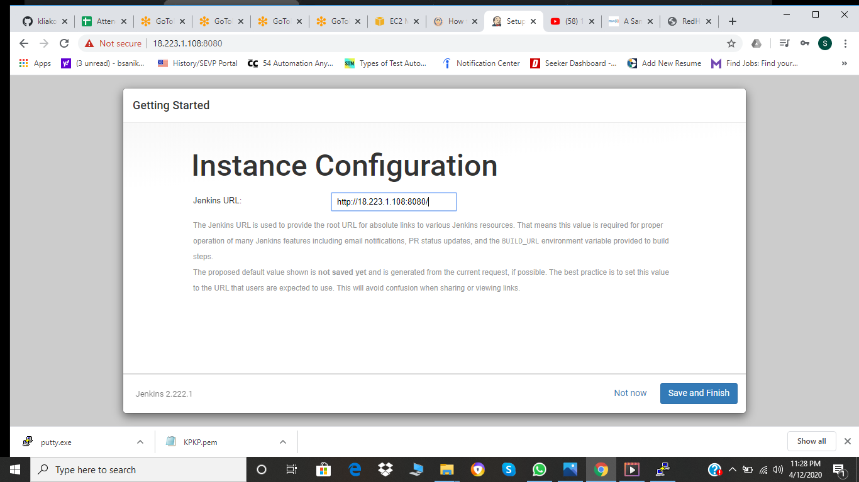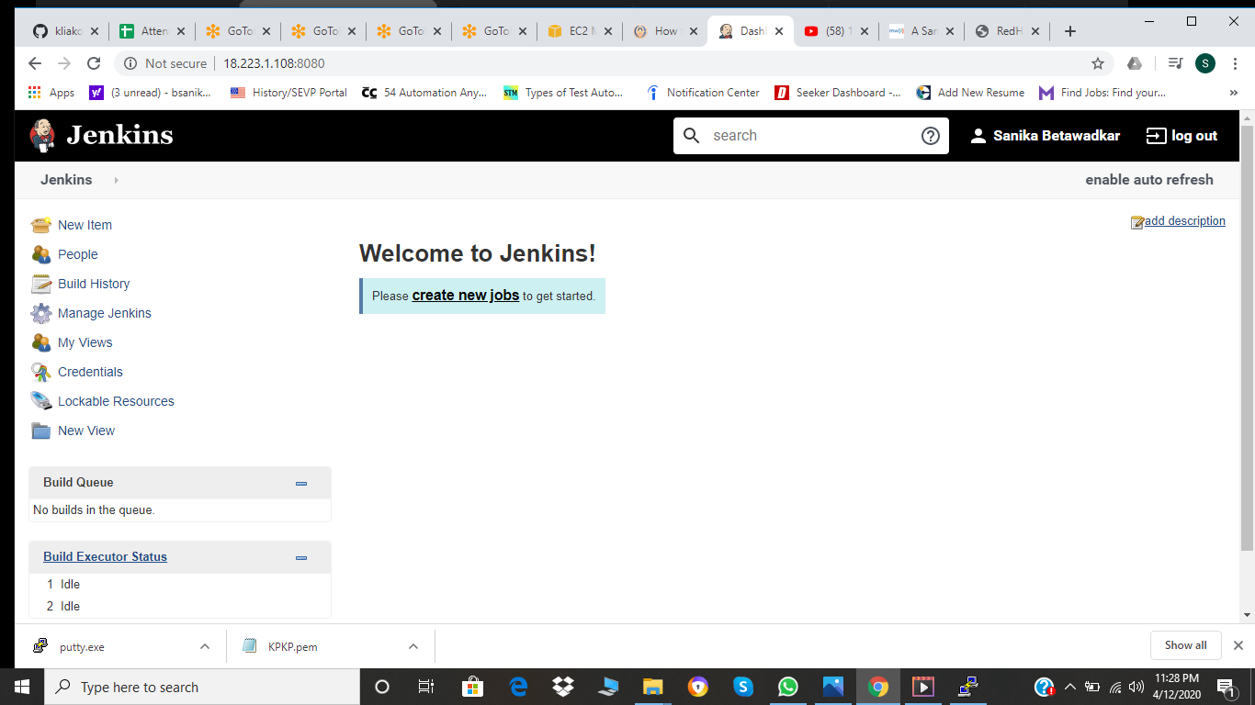

Then as we need to have git repository we need to have git installed

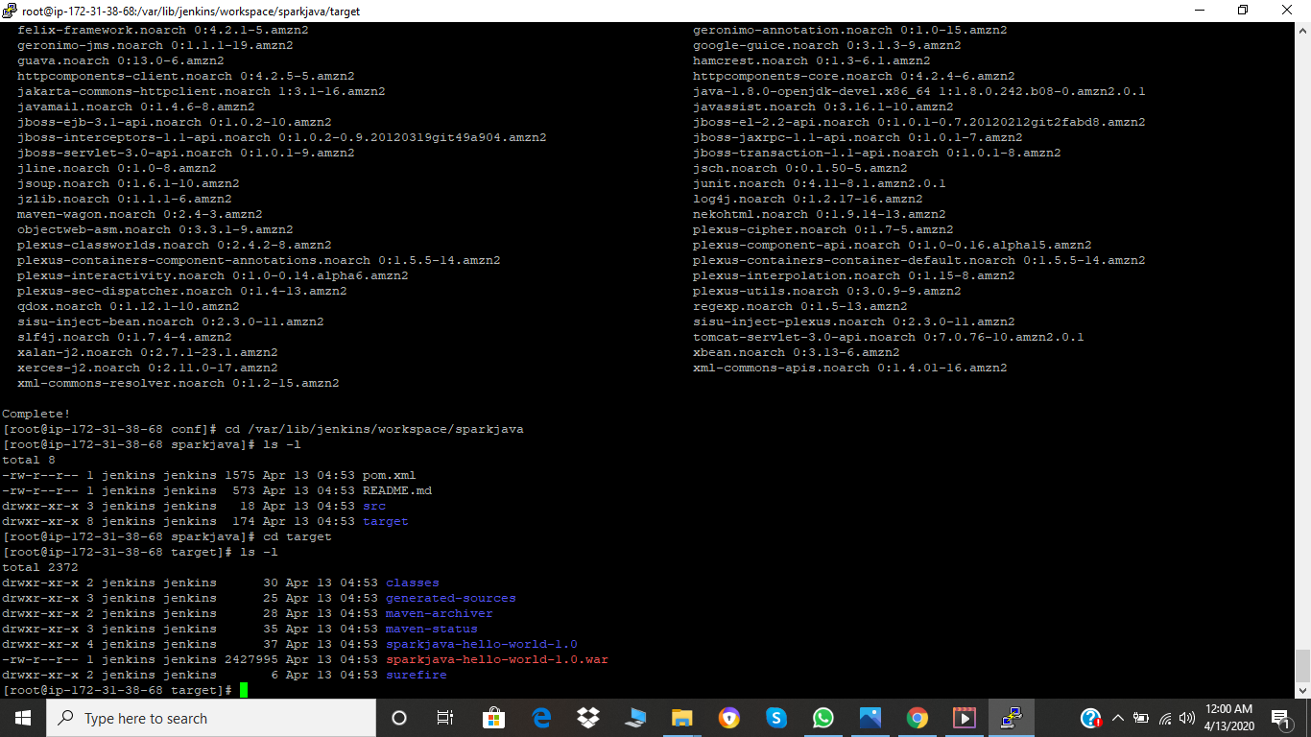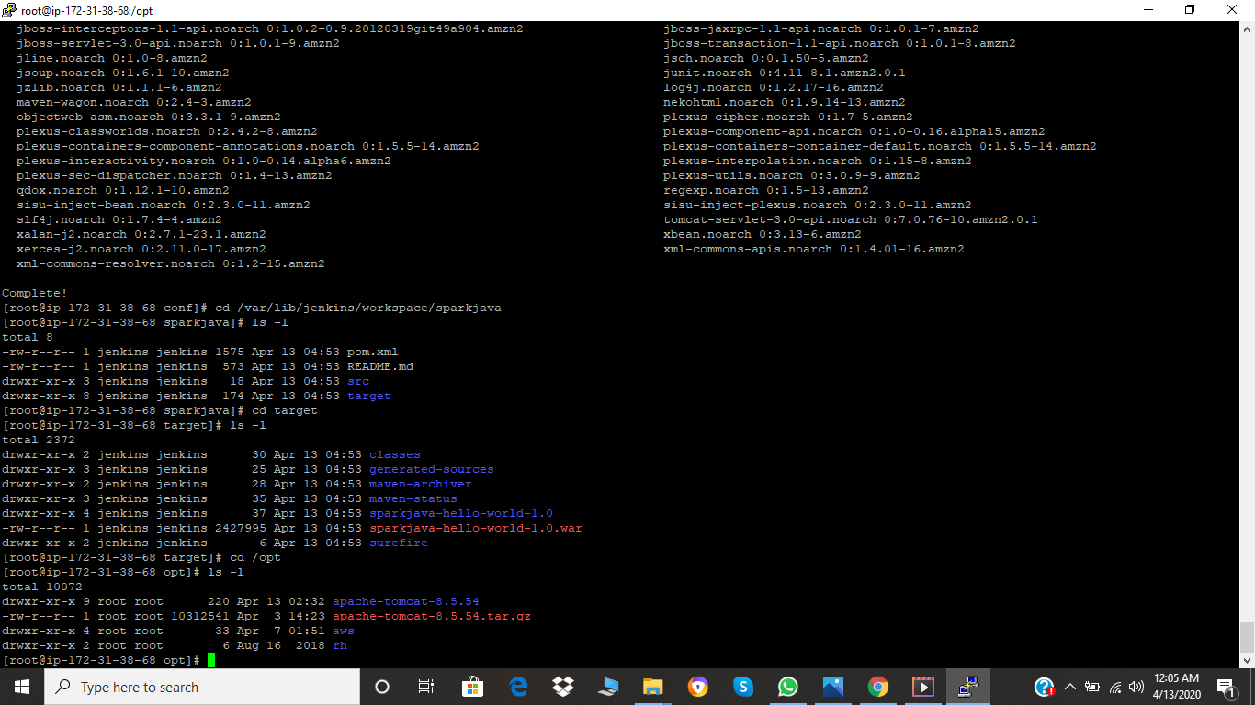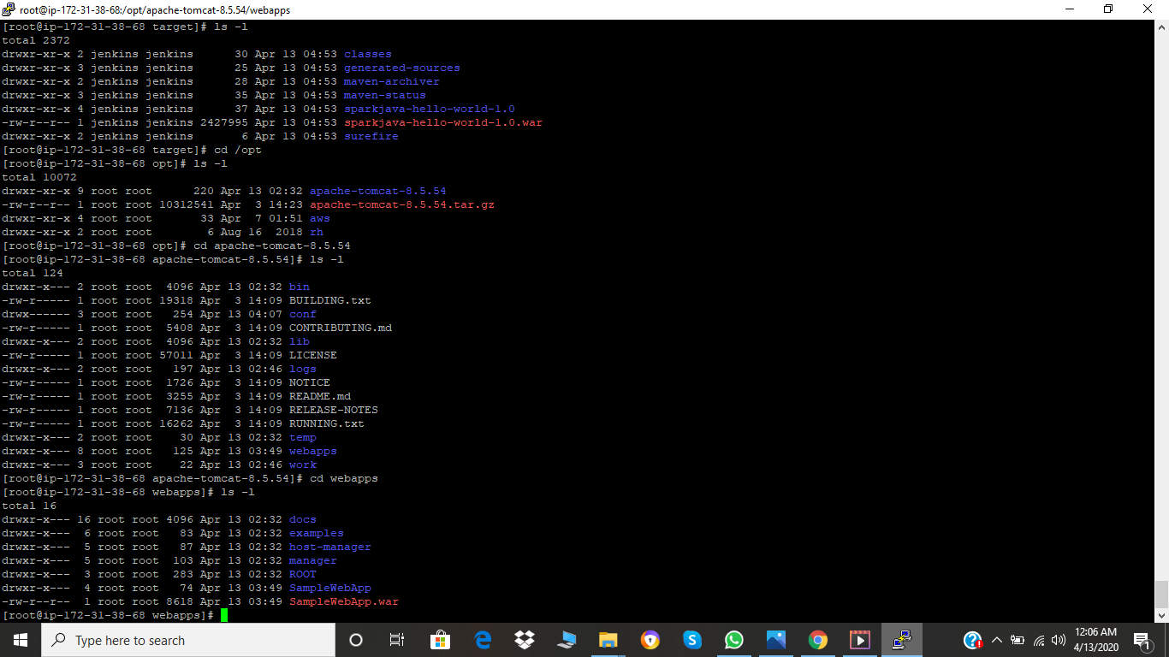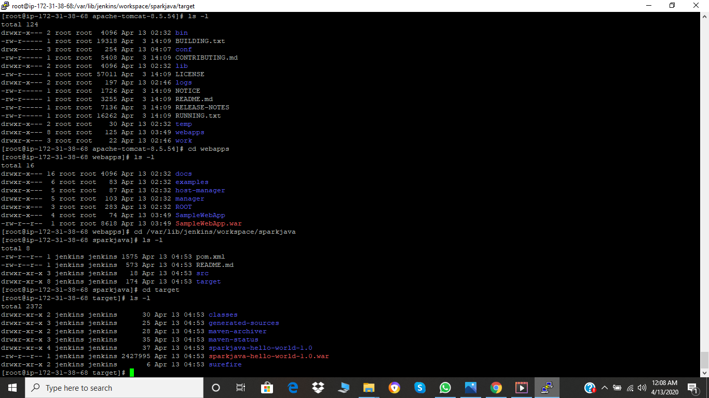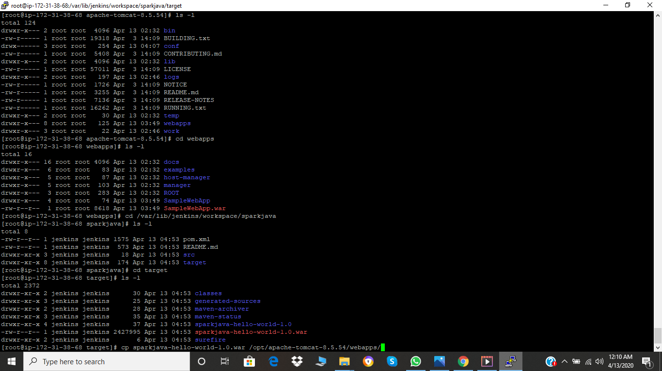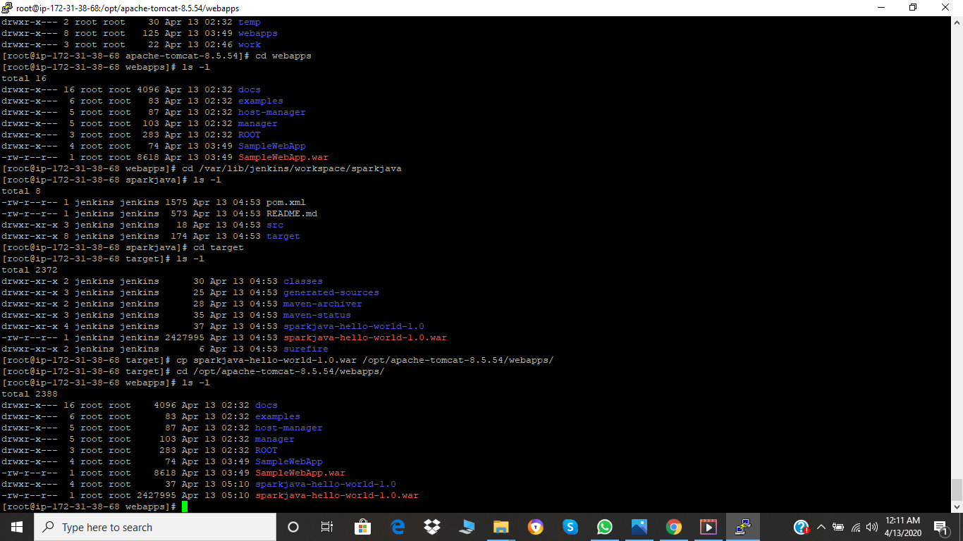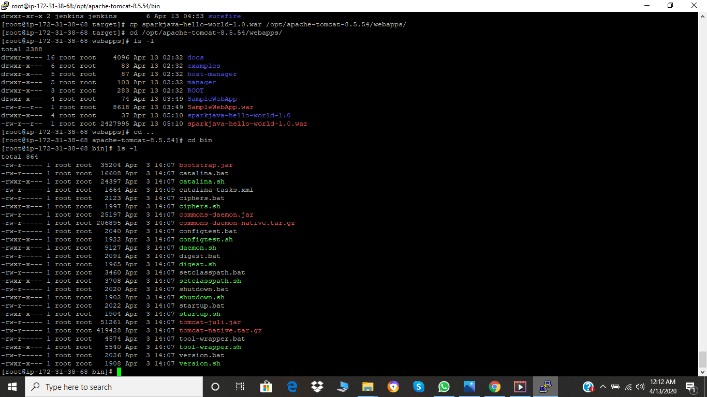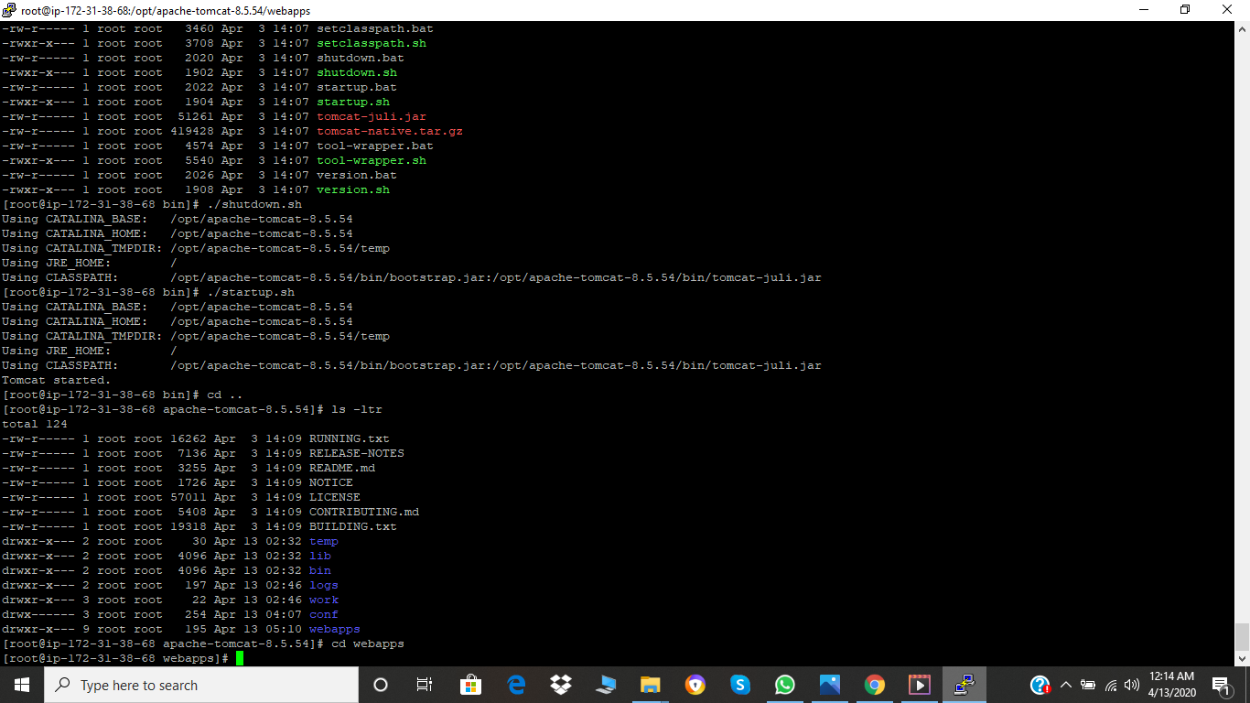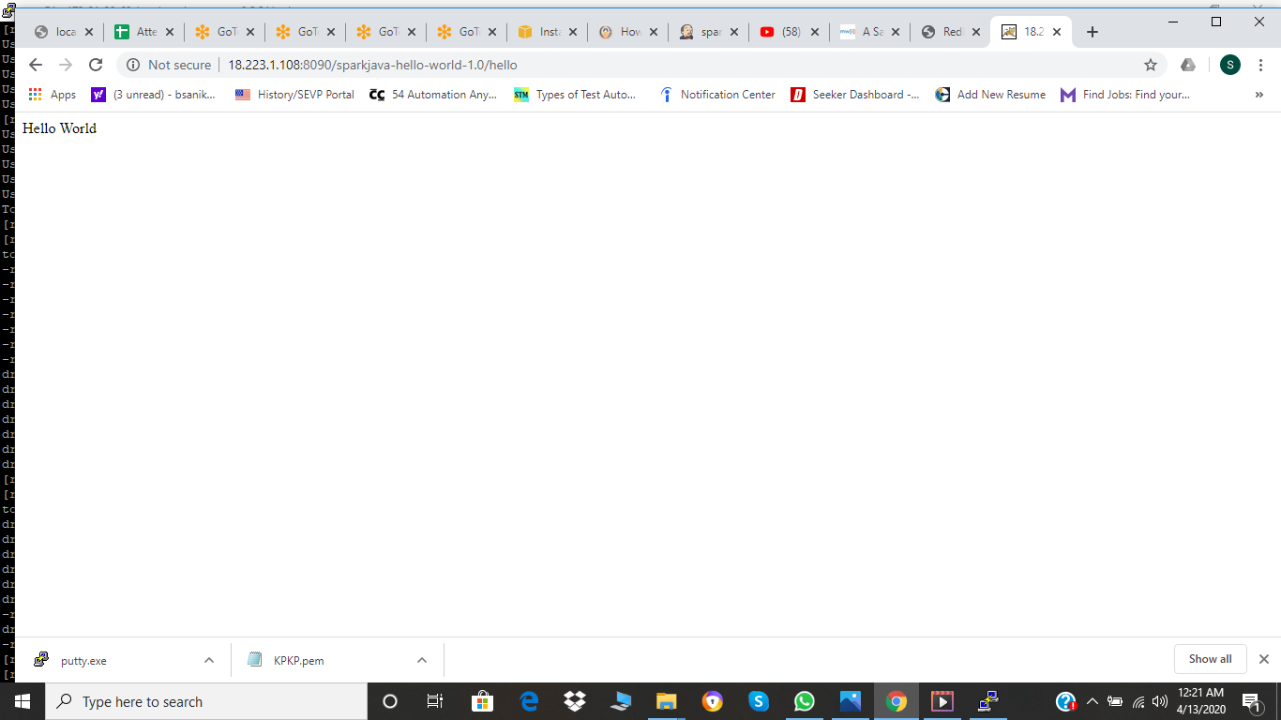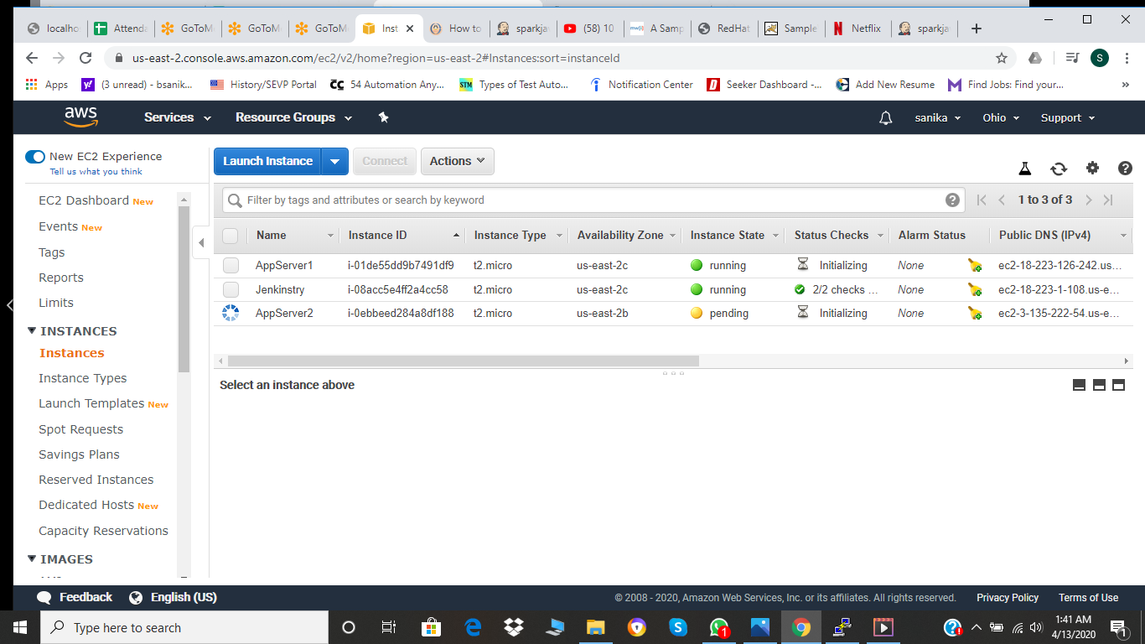

Then we need to have two instances as we have to publish it on them so create those instances same way as the 1st and name them as appserver1 and appserver2. We need to download tomcat on both the servers.

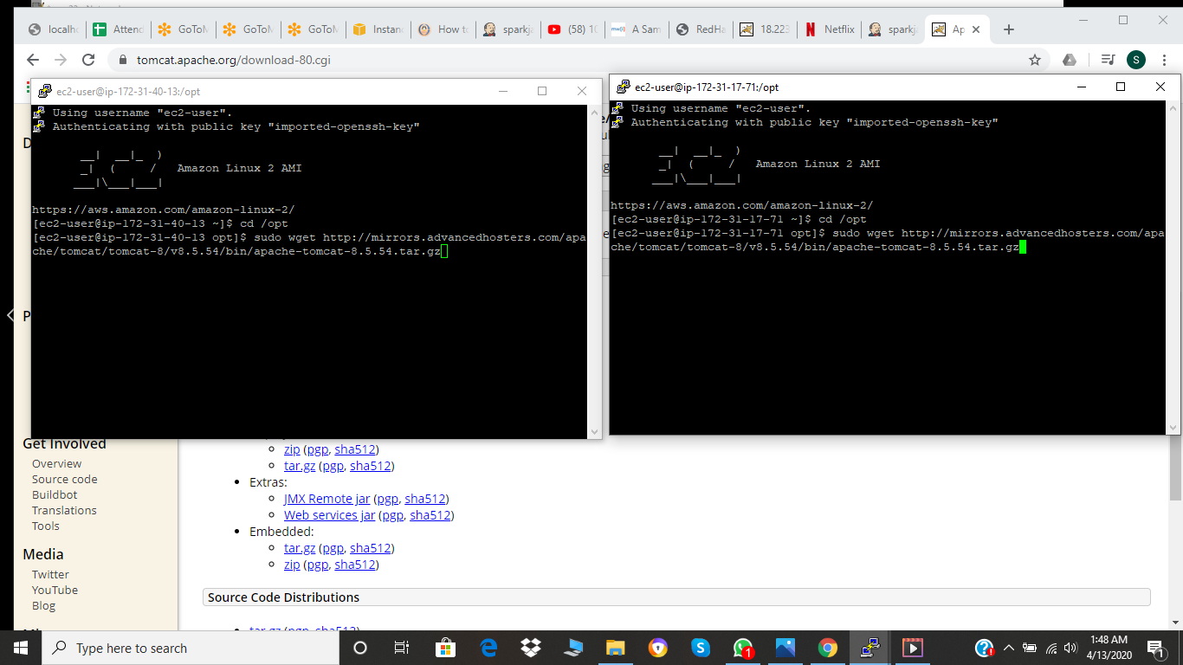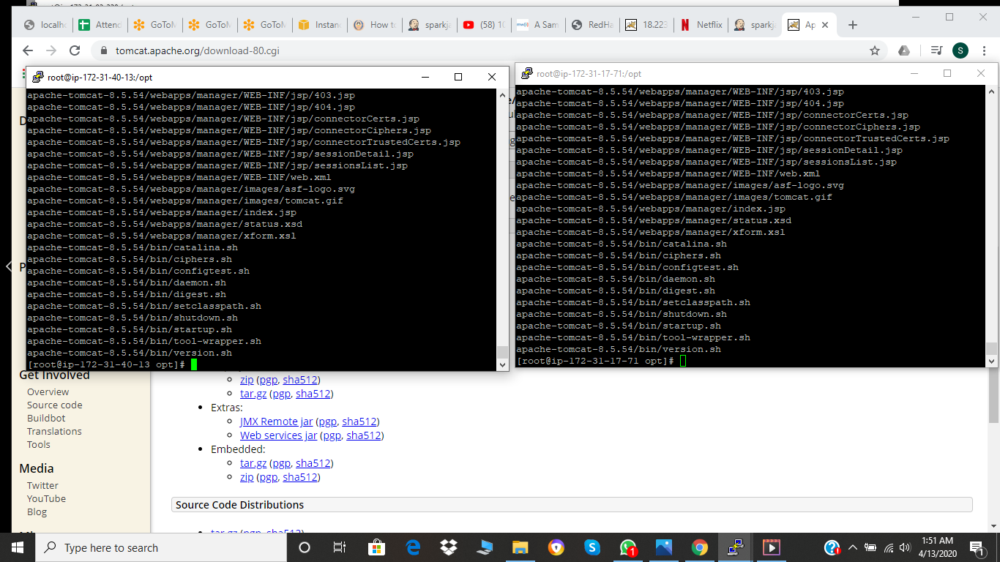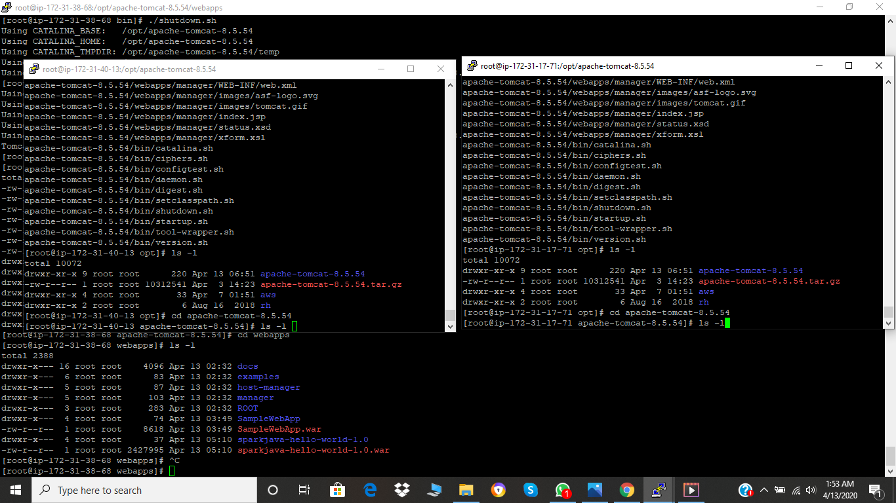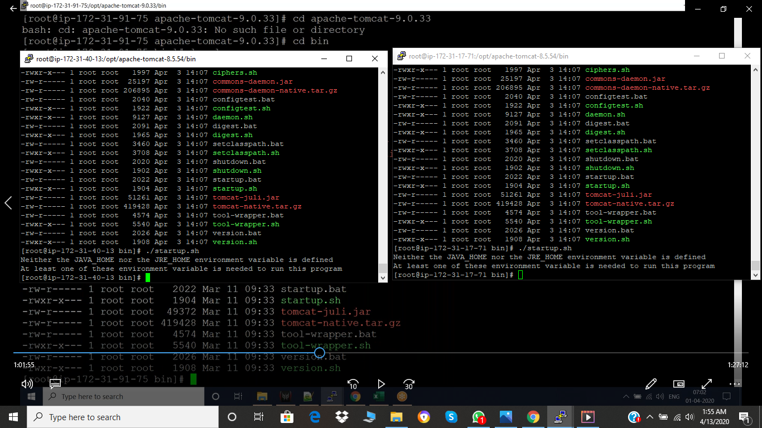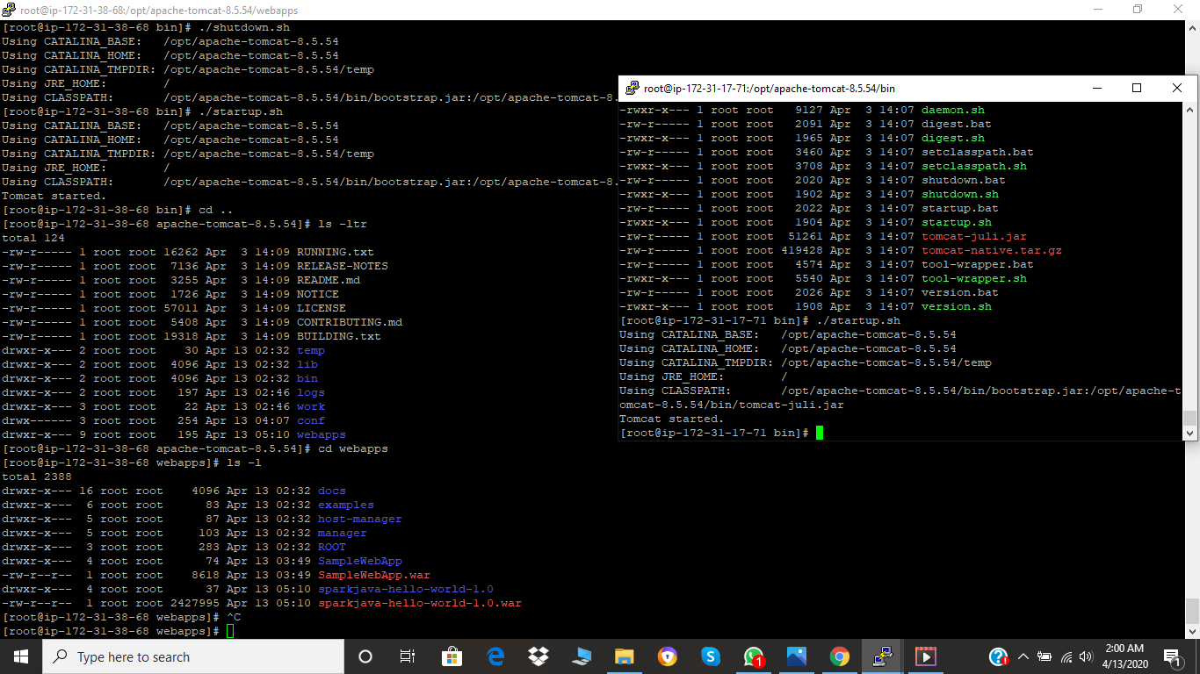

Then we have to do maven build to represent it on the server

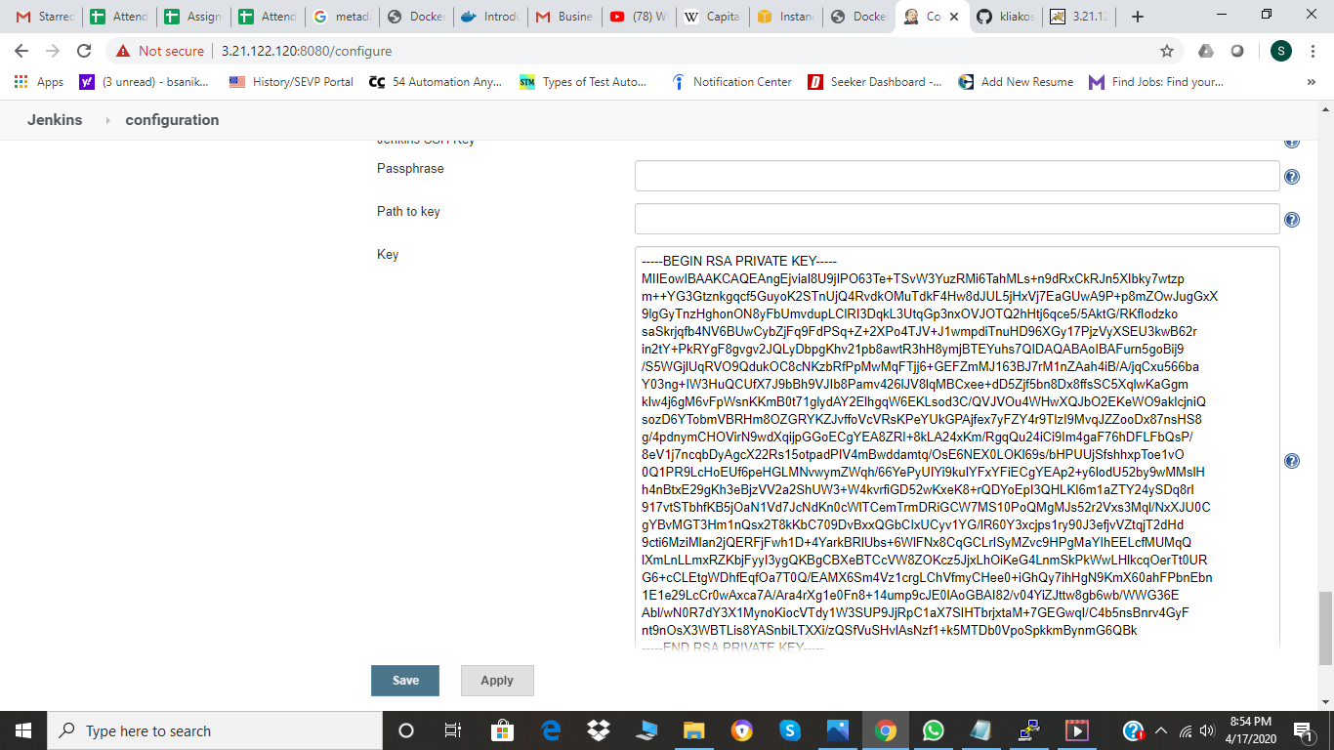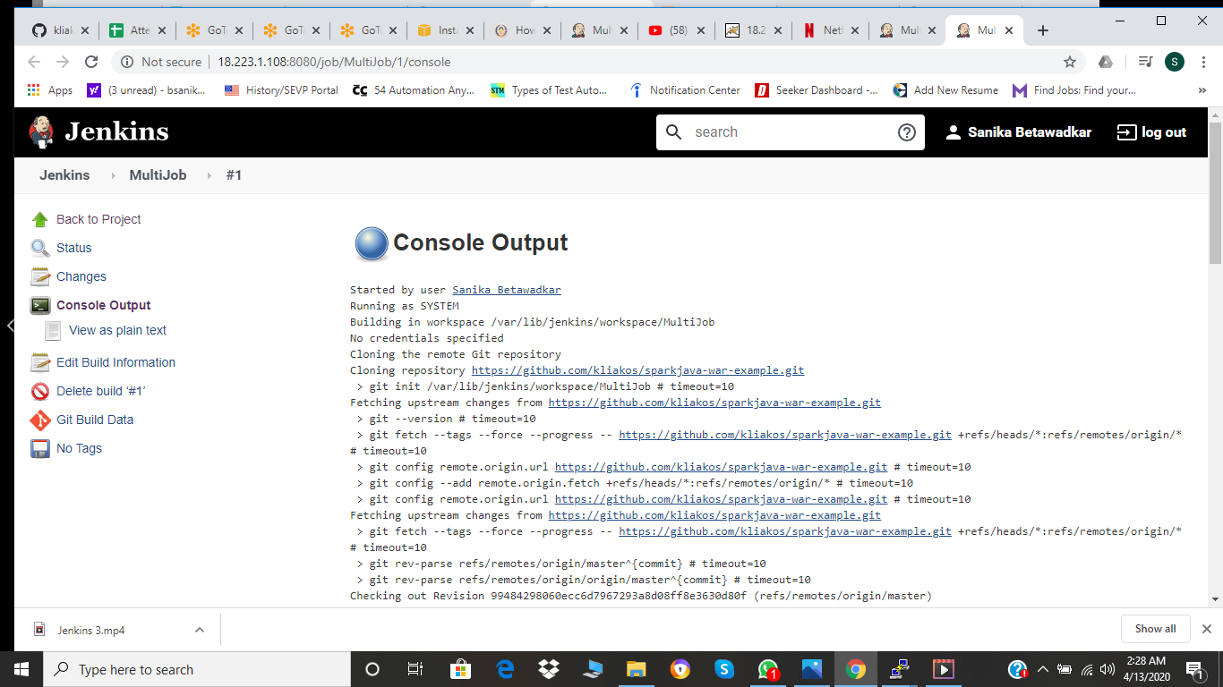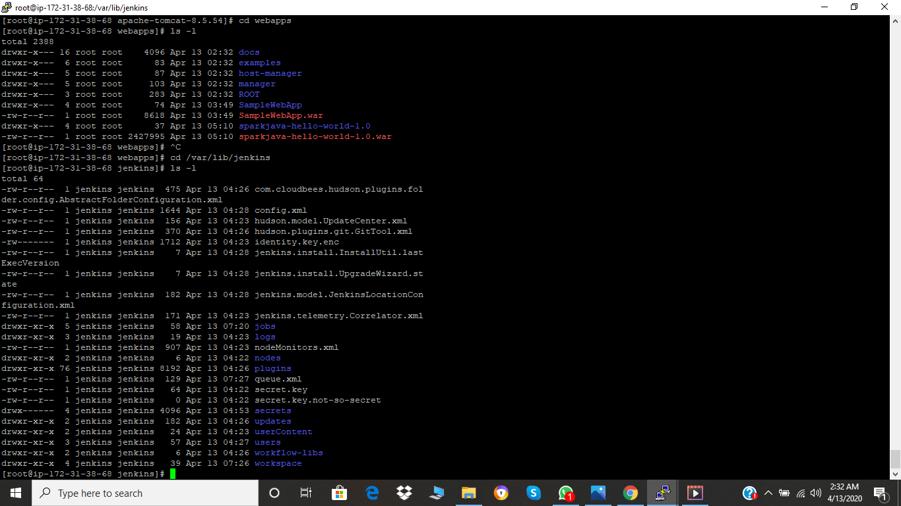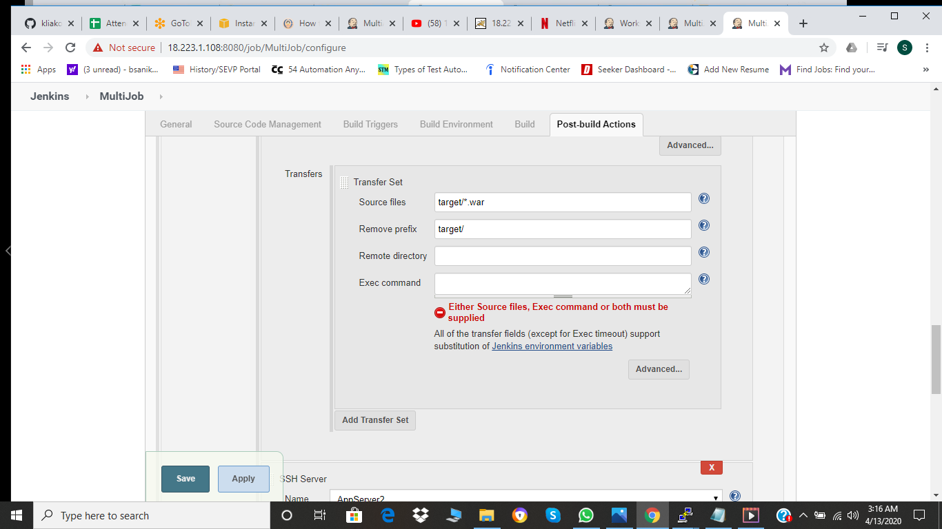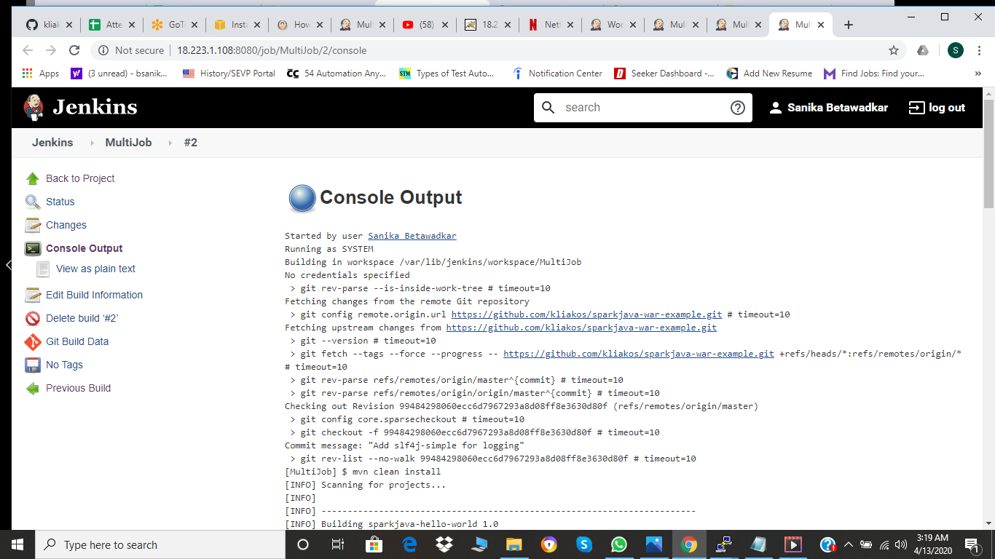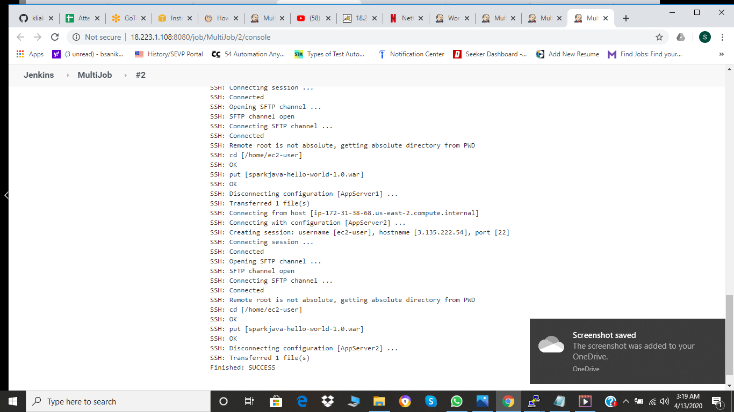

So now after this as it is represented on both the servers.

But say if maven build fails then the project will fail and we will loose everything so for that we can create jobs for each steps.

1. Git Download
2. Maven clean install
3. Copy those instances

So after creating these projects we can just build them so now we have 3 projects.

Now we have to run them sequentially then only we will get defined output or else not.

So we need to create pipeline script and for that we have to create pipeline script and create a pipeline scm with the help of grovy script which is java based.

pipeline{

agent any

stages {

stage ('Copying Repository') {

steps {

echo '\*\*\*\*\*\*\*\*\*\*\*\*\*\*\*\*\*\*\*\*\*\*\*\*\*\*\*\*\*\*\*\*\*\*\*\*\*\*\*\*\*\*\*\*'

echo 'Copying Files to Tomcat Server'

build 'GitDownload'

echo '\*\*\*\*\*\*\*\*\*\*\*\*\*\*\*\*\*\*\*\*\*\*\*\*\*\*\*\*\*\*\*\*\*\*\*\*\*\*\*\*\*\*\*\*'

}

}

stage ('Maven Build') {

steps{

echo '\*\*\*\*\*\*\*\*\*\*\*\*\*\*\*\*\*\*\*\*\*\*\*\*\*\*\*\*\*\*\*\*\*\*\*\*\*\*\*\*\*\*\*\*'

echo 'Running into Maven Build'

build 'MavenBuild'

echo '\*\*\*\*\*\*\*\*\*\*\*\*\*\*\*\*\*\*\*\*\*\*\*\*\*\*\*\*\*\*\*\*\*\*\*\*\*\*\*\*\*\*\*\*'

}

}

stage ('Transfer War Files') {

steps{

echo '\*\*\*\*\*\*\*\*\*\*\*\*\*\*\*\*\*\*\*\*\*\*\*\*\*\*\*\*\*\*\*\*\*\*\*\*\*\*\*\*\*\*\*\*'

echo 'Transfering War Files to App Server'

build 'TransferWarFiles'

echo '\*\*\*\*\*\*\*\*\*\*\*\*\*\*\*\*\*\*\*\*\*\*\*\*\*\*\*\*\*\*\*\*\*\*\*\*\*\*\*\*\*\*\*\*'

}

}

}

}

You can stroe than in the git repository and filnally a pipeline is created.s